## Republic of the Philippines

## Province of Camarines Norte

## Municipality of Paracale

## Barangay Gumaus

# OFFICE OF THE PUNONG BARANGAY

CERTIFICATE OF INDIGENCY

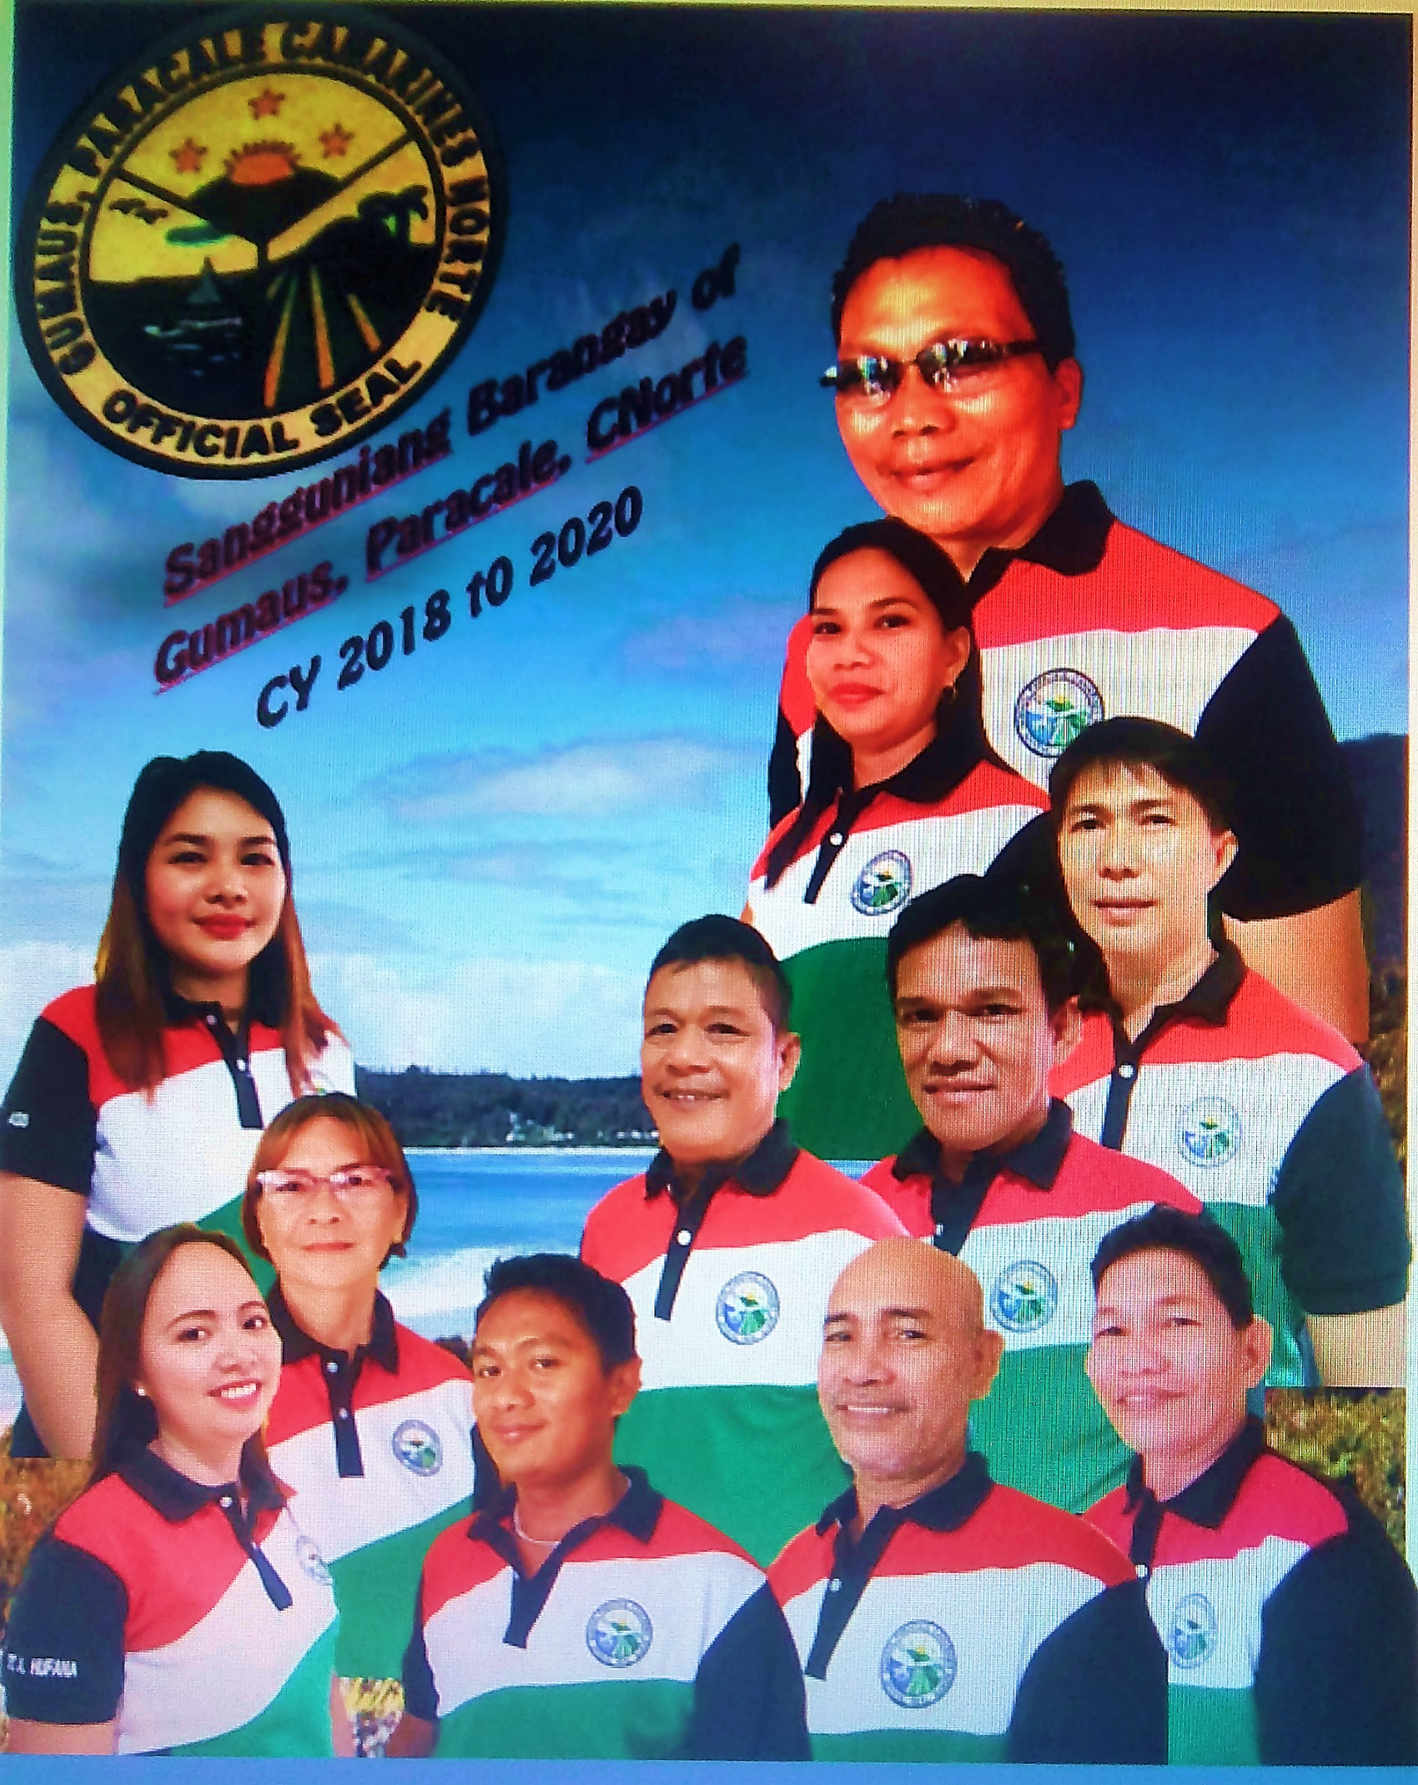

TO WHOM IT MAY CONCERN:

This is to certify **Jessa C. Barro,** with residence and postal address at Purok-7 Barangay Gumaus, Paracale, Camarines Norte is one among indigent families living in our barangay.

Issued upon the request of the interested party for **request of Medical Assistance.**

Given this 8th day of February**,** 2024 at Barangay Gumaus, Paracale, Camarines Norte.

ARLAN M. PAITAN

*Punong Barangay*